

- Click Create/Edit Site Button – enter your site (use http://yoursite.com/fce/) enter your user name and password ; click ADD button and OK
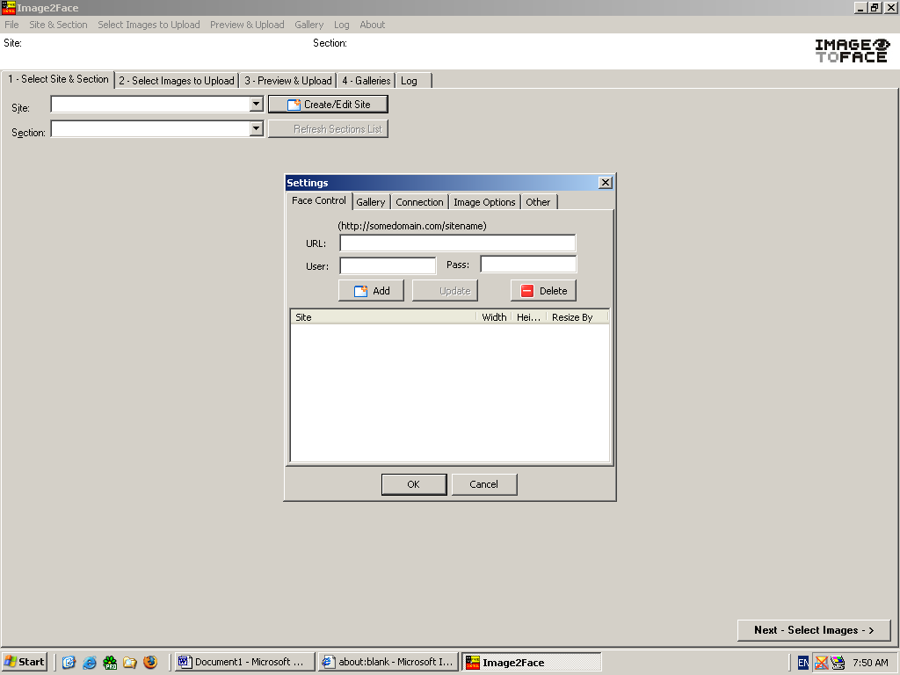
- Select your site from drop down edit – SITE.
- Click REFRESH SECTION LIST.
- Select SITE and section you want to create galleries in (SECTION drop down button).
- Click Next – Select Images button at the bottom of the screen
- Select Images to upload (you may use ADD FILE TO CURRENT SECTION BUTTON to add selected images or ADD ALL FILES TO CURRENT SECTION to add all files from current folder).
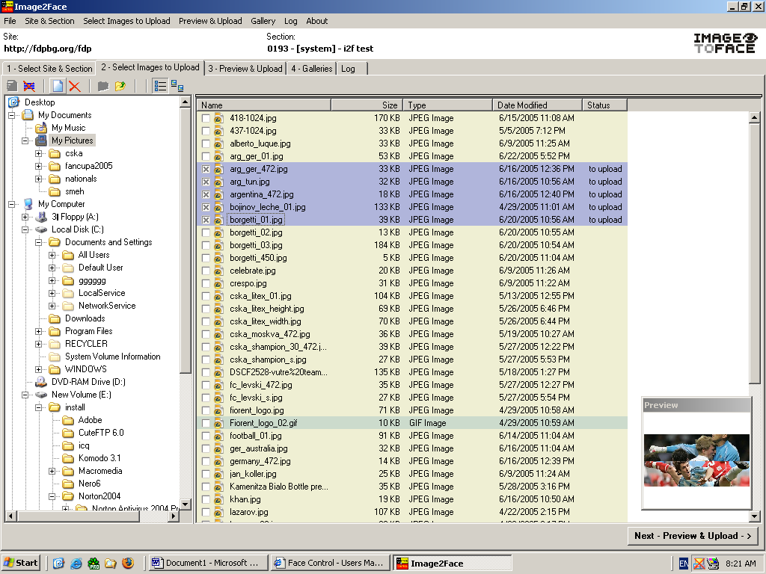
If you don’t see the images your Windows Explorer hides the extensions for file types.
- From Windows Explorer menu choose Tools > Folder Options…
- On the View tab on Folder Options remove the tick across Hide Extensions for Known file Types. Click on OK button.
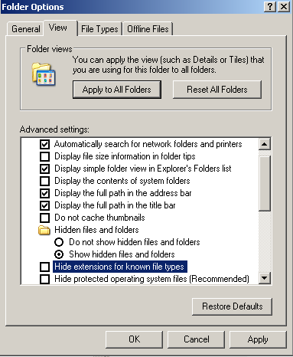

- Click on Next – Preview&Upload Button at the bottom of the screen
- You can upload images or create galleries .
- For creation of galleries use GALLERY FROM SELECTED or GALLERY FROM ALL buttons.
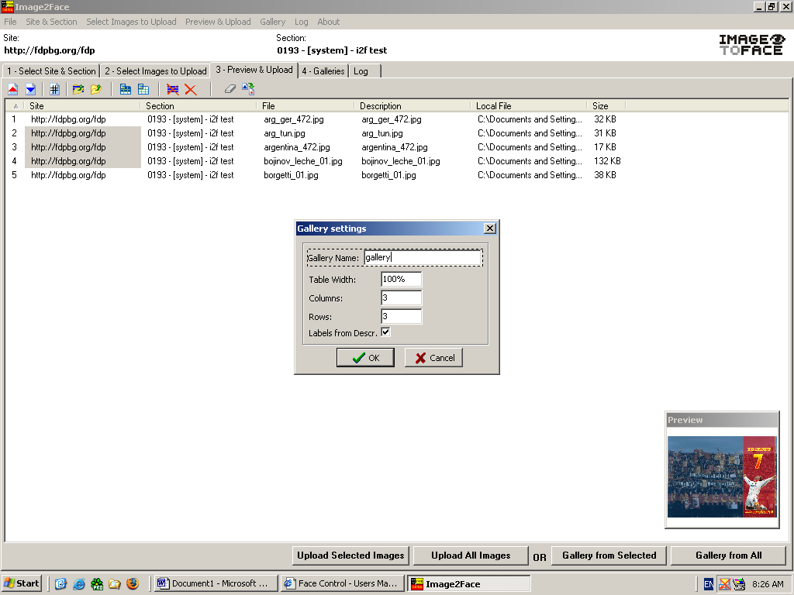
- In gallery settings put number of rows and columns and default gallery name
- You can rearrange image’s order using arrows UP and DOWN. You may also use different order (e.g. by NAME) and rearrange order after clicking # button
- You can edit descriptions by clicking F2 key
- You can clear descriptions by clicking CLEAR DESCRIPTIONS icon (no text will appear below the images in galleries)
- You can create external gallery file for easier editing by clicking EXPORT TO GALLERY FILE icon (save file as TXT file – you can copy and paste it’s content in MS Excel) after editing descriptions in excel you can copy them back in txt file for creation of galleries
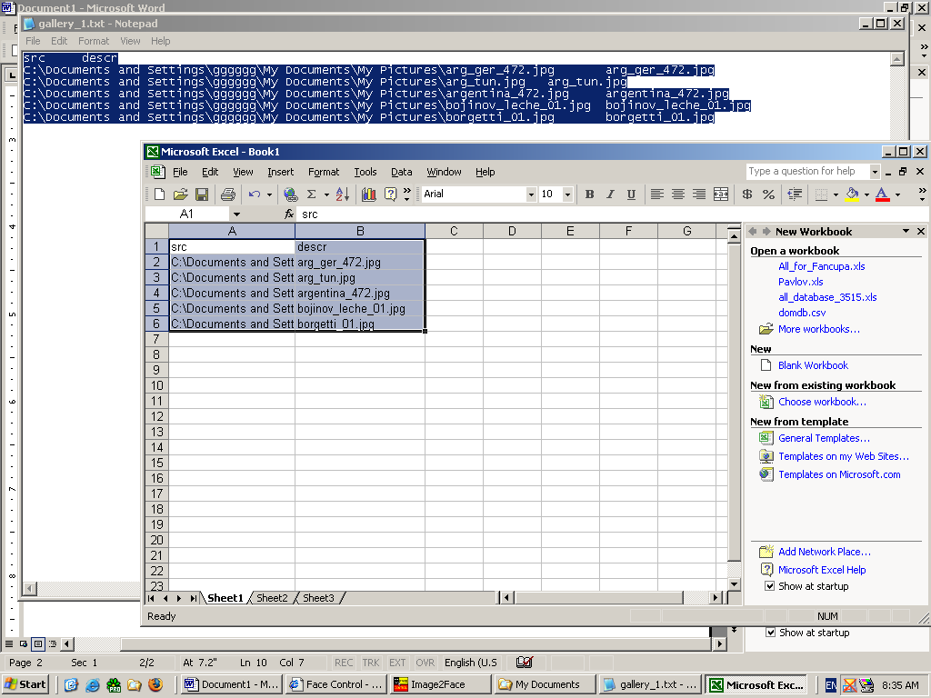
- On galleries page (4) you can UPLOAD created galleries or EDIT them.
To Edit a gallery double-click on its name or use the Edit Gallery Button.
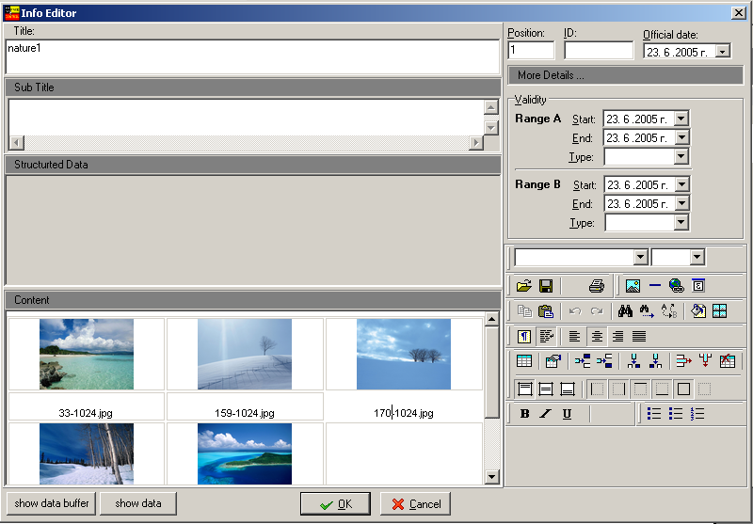
- You can also create galleries from file (see 14)
- Click on Upload Selected Galleries or Upload All Galleries Button.
- After uploading of galleries or images uploaded images will be deleted from IMAGE2FACE .
- NB Uploaded galleries are UNPUBLISHED.

