

Face Control
Quick Start

1 Basic Terms 2
2 Log In 3
3 INFO ENTRY 3
3.1 Create your first info 3
3.2 Insert text 4
3.3 Tools - some buttons you need to know to integrate content 4
3.4 Add Images 5
3.5 Create and Format Tables 5
3.6 Adding Downloadable Files (pdf, doc, zip, mp3, mpeg, etc) 6
3.7 Inserting Internet or Mail links 6
3.8 Advanced insert links 6
Inserting Internet, Mail on text or image 7
Inserting Internal Links 7
3.9 Save your first info 7
4 EDITOR CONTROL 7
4.1 Publish infos 7
4.2 Edit infos 7
4.3 Find an info for editing 8
4.4 Unpublish infos 8
4.5 Move and copy infos 8
5 Create a new section 9
6 Edit an existing section 9
7 Add section to main menu 10
8 Use Visualization Management 11
8.1 To load a visualization for a section... 12
8.2 To add a section .... 12
9 Site Statistics 13

Basic Terms

· INFO - single independent complete information on your web site. It could be an article, a picture, a table, or a combination of the tree. There are two ways to display an info - as INFO LINK or as INFO COMPLETE.
· CONTENT- the body of the INFO. This is the very text, table or picture that is put into the INFO - the filling of the INFO.
· TITLE- the title of the INFO is the title of the information contained in the info.
· SUBTITLE - a short resume of the INFO. It could contain text and pictures.
· INFO LINK - an INFO which is displayed as a link only, and in order to be viewed the link should be followed. Usually this is the TITLE and the SUBTITLE of the INFO, which lead to the INFO COMPLETE.
· INFO COMPLETE- a fully displayed INFO. Usually the TITLE and the CONTENT of the info are displayed.
· SECTION - a part of the web site in which similar INFOs are gathered and displayed to the visitor. For example "Home" or "About us" are two different sections.
· SECTION LINK - it speaks for itself - this is a link to a section. For example, a section link is every link of the main menu.

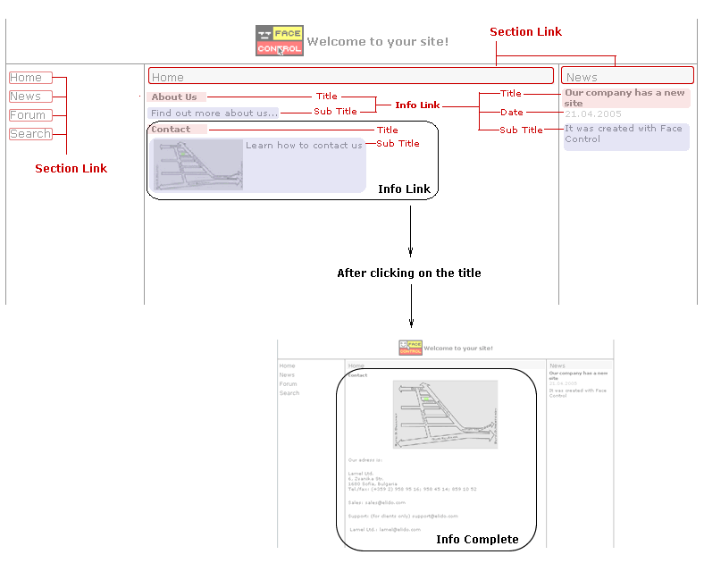

Log In

Administrative control is available through Internet. In the Address bar of your browser type the name of your site followed by /fce/admin (e.g. http://YOURSITE/fce/admin). A dialog window will open. Enter your Username and Password and click Login.

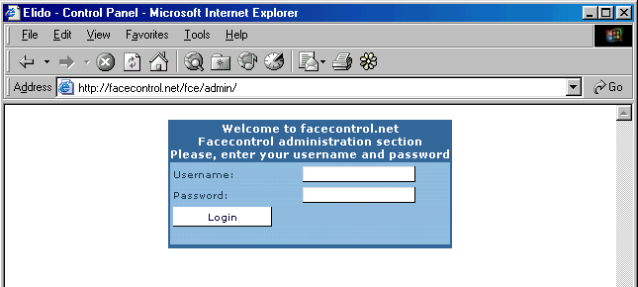

After successful login the Face Control menu will open.

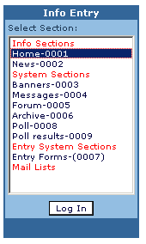
INFO ENTRY

Create your first info

After you have logged in, choose Info Entry from Face Control menu. A dialog box will appear.
Choose the section in which you want your info to be seen and click Log In. The screen of the Info Entry panel will open.

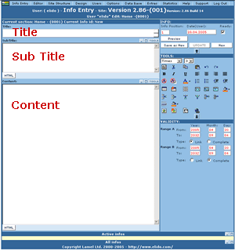
To create one info you have to fill up three fields:
1. The Title of the info (obligatory).
2. The Content of the info. This is the information you want to store in the info - it could be text, pictures or tables.
3. The Sub Title of the info. The Sub Title is a short resume of the content. It could contain text and pictures.

Insert text

To insert text you just need to type it in the Content field or in the Sub Title field. You do not need to format the text here unless you want to apply any other formatting than the default formatting of your site. You can as well paste text from some other text document.

Tools - some buttons you need to know to integrate content

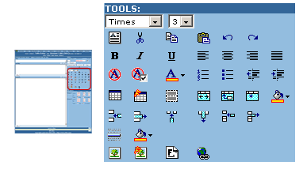
Insert Table
Format Table
Format Cell
Visible Borders
Insert Image
Format Image
Insert File
Insert Hyperlink
Advanced Remove Formatting

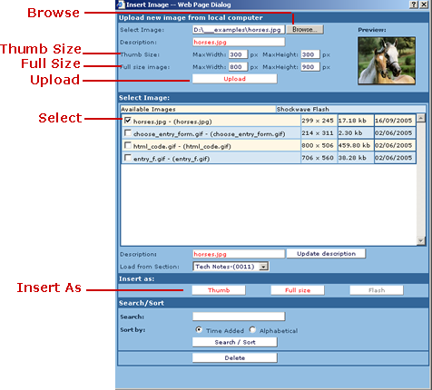
Add Images

1. Click the Insert Image button. A dialogue box appears.
To insert an image in your info you should first upload it from your local computer on the server, otherwise the image will not be available when you stop your computer. If you have any uploaded images on the server they will appear in the list of available images.
2. Click Browse and select an image from your local computer.
3. Click Upload to upload the image on the server. Depending on your Internet connection you may have to wait a few seconds. When the image uploads it will appear in the list of available images.
4. Position the mouse in the content field of your info where you want to insert the image. Select the image from the available images list.
5. Click on the button Insert As Full size to insert the image.
You can insert the image either as Thumb or as Full size(image in original size). When you insert the image as a Thumb a smaller image will appear in the content field. When you click on it in your web browser a new window containing the image in original size will open. If you want to change the Thumb size or the Full Size you must define it before the image upload.

Create and Format Tables

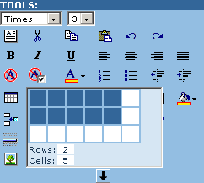
1. To insert a table in the content of the INFO, push the cursor at the point of the content you want to integrate the table and click the Insert Table button. Set the number of rows and columns.
2. Select the table by placing the mouse over the border until the cursor turns to a cross.
Select the Format table button. A dialog box appears. You can then:
- Align the table
- Set the width and height (to be a certain number of pixels or as a percentage of the page). E.g. - If you set the width to 50%, the table will extend half the width of the screen, no matter what size.
- Specify the cell spacing (the amount of space between the borders of the cells, cell padding (the amount of space between the actual content of the cell and the cell border), border width and color, background color.
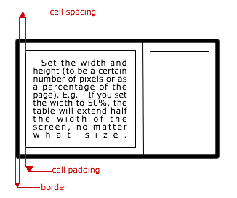
If you set the table border to 0 you can use the Visible Borders button to view the table. In this case the borders will not be visible on the site but only in Face Control.

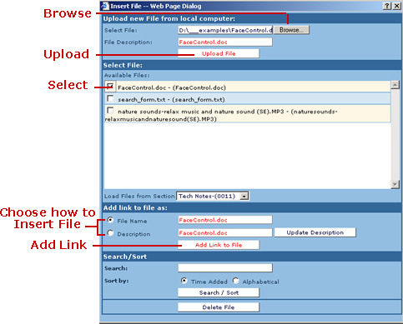
Adding Downloadable Files (pdf, doc, zip, mp3, mpeg, etc)

1. If you want to integrate files in the content, click on Insert file button. A dialogue box similar to the image one appears.
2. If you want to upload a File from your computer click the Browse button and chose the respective file. Then click on Upload File button. The file will be uploaded on the web server and will appear in the Available Files list.
3. Select the file you want to insert and choose how to insert in:
- As File name - inserts the name of name of file which is a link to the file itself;
- As Description - inserts the description of the file which is a link to the file itself;
To Change the Description write the new description in the respective box and click Update Description.
4. Place the cursor in the content field of the info where you want to place the link to your file and click the Add Link to File button.

Inserting Internet or Mail links

You can just type desired web link or e-mail in the content field. It will be transformed to a hyperlink. If you have pasted text to content control you can position mouse at the end of the text of the desired link and hit the Space bar.

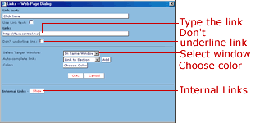
Advanced insert links

Inserting Internet, Mail on text or image

1. Select the desired text or image in the Content Field. Click Insert Hyperlink button. A dialog box will open.
2. Type the desired link it the respective field. If it is an Internet link it should begin with http:// (i.e. http://facecontrol.net). If it is a mail link it should begin with mailto: (i.e. mailto:support@facecontrol.net).
3. You can choose if the link will be opened in the same or new window from the Select Target Window drop down menu. Also you can choose the color or the underline of the link as well as the link text.

Inserting Internal Links
1. If you want to integrate a link to other section or info of your website, click the Insert Hyperlink icon. Click the SHOW Internal Links button. Choose the respective internal link.
2. You can also select the link to be opened either in the same or in new window. You can choose the link text and you have the option don’t underline link.

Save your first info
After you fill in these fields, click Save as New. The Update button is used when you edit an already existing info.

N.B. The information you have just created will not be visible on your website until you publish it.

EDITOR CONTROL

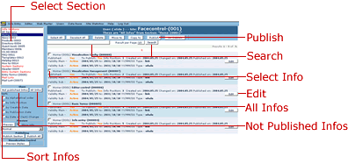
Publish infos

1. From the Face Control menu choose Editor > Editor Control.
The shown window will open. By default the infos that are not published will be displayed.
2. Select the info you want to publish and click the Publish button.

3. Select Yes on the question "Are you sure you want to Publish the following infos?"

Edit infos

1. From the Face Control menu choose Editor > Editor Control.

2. Select the section where your info is stored and click the button All infos. All infos in the selected section will be displayed sorted by default by Info Position. Find the info you want to edit and click the respective Edit button. The screen of the Info Entry panel will open in a new window with the content of the chosen info.
3. Make the changes and choose the Update button in the Info Entry panel.

N.B. The changes will not be displayed until you publish the info.

Find an info for editing
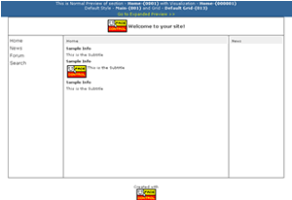
Sometimes when you surf through your site and you want to edit some info, it is difficult to determine to which section this info belongs. The easiest way to reach the info is to use Normal and Expanded Preview.

1. From the Face Control menu choose Editor>Normal Preview. A new window will open with a blue hat containing system information. This is Normal Preview.

2. Surf through your site in through your site until you reach the desirable info.

3. Click on the link Go to Expanded Preview >> in the blue hat.

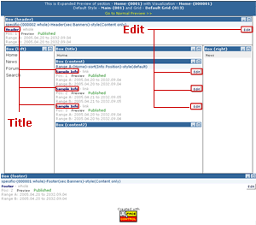
In Expanded Preview you can see your site with extra system information. Here you can have the visualization, the grid and the default style of the current section.

4. Examine carefully Expanded Preview and when you find the title of the desirable info click on the corresponding Edit button. In a new window Info Entry panel will open, containing the chosen info for editing.

Both in Expanded and Normal Preview you can use links (section links and info links) to move along through your site. You can as well switch trough the previews using the link in the blue hat until you reach the desired info.

Unpublish infos

To unpublish an info you should select it and click on the Unpublish button. Unpublished infos will not be seen on you site but will be seen in Editor Control. If you want to remove an info from Editor Control you should select it and click on the Delete button. Be careful because when you delete one info it will not exist afterwards.

Move and copy infos
You can select all infos or just one info in order to move or copy them to another section.
N.B. After you have moved or copied info to another section you should then publish it.

Create a new section

1. From the Face Control menu choose Site Structure>Sections. The shown window will open.

2. Type the names of the new section.
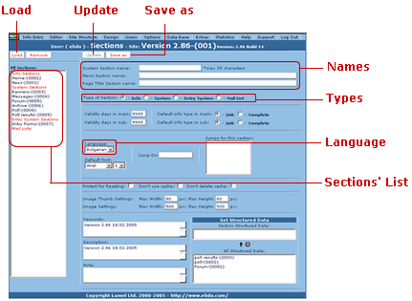
- System Section name - this is the name that will be used inside Face Control. It will not be visible on your website.
- Menu Section name - this is the real name of the section. It will be visible on your site.
- Page Title Section name - this is the name that will be visible in the title bar of your web browser (e.g. the Page Title Section name of section Home could be "Welcome to my page!").
It is recommended that the three names are the same.

3. Choose the type of the section.

4. Choose the language for the section.

5. Click on Save as button to save your section.
N.B. To see the new section on your site you must add a link to it in the main menu or in Visualization Management.

Edit an existing section

1. From the Face Control menu choose Site Structure>Sections.

2. Choose the section you want to edit form the sections’ list and click on the Load button.

3. Make the changes and click on the Update button.

Add section to main menu

- From the Face Control menu choose Site Structure > Group editor. The shown window will open.

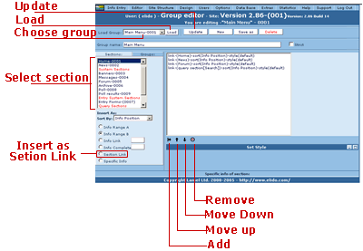

2. Choose the group of the main menu (usually named Main Menu) and click on the Load button. You will see links to sections that represent the main menu.

3. Select the section you want to add and click on the Insert as Section Link radio button.

4. Click on the Add button. You will see a new link added in the group (e.g. link-(My Section)-style(default)). With the Up and Down arrows move the new link to the desired position.

5. Click on the Update button.

Use Visualization Management

Visualization Management is the place where you define the way of showing the information on your site. Visualization Management contains Boxes which correspond to imaginary cells on your site (see the image). By adding content to the Boxes in Visualization Management you define the structure of your site. In Visualization Management you define the rules for showing infos in your site.

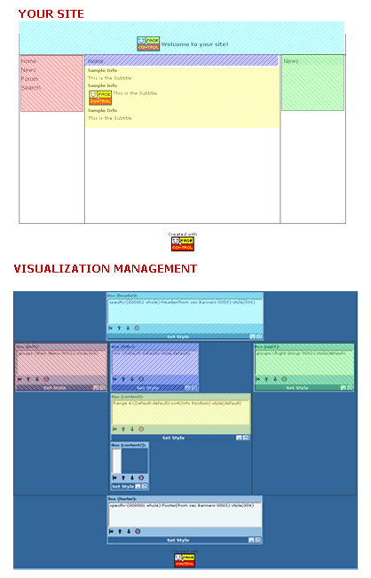
From the Face Control menu choose Site Structure > Visualization Management. The visualization for the first page of your site will open. In the field Current Section you should see the name of the section which is first loaded when you type your address in your browser (usually section Home). In the field Current Visualization you will see the visualization that is attached to the Current Section.

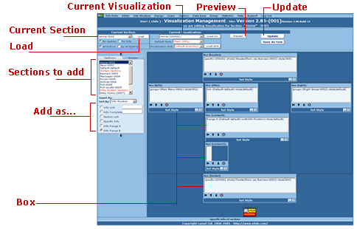

To load a visualization for a section...

Choose the desired section from the Current Section field and click on the Load button. The respective visualization will load.

To add a section ....

1. Choose the desired section from the list Section to add.

2. Choose the way you want to add it:
- Info Link - adds all infos from the chosen section as info link; if you write a number, e.g. 3, in the corresponding field, then first 3 infos will be shown as info links;
- Info Complete - adds all infos from the chosen section as info complete; setting the number of infos is also allowed;
- Section Link - adds a link to the chosen section;
- Specific Info - gives the opportunity to select exact info and show it. Usually used for banners.
Click on specific and scroll down to the bottom of the window. A list of infos from the Current Section will be shown. You can perform search or sort infos to find the info you need. Select the type of the info - insert it as info link or as info complete and place a tick in the Select box.
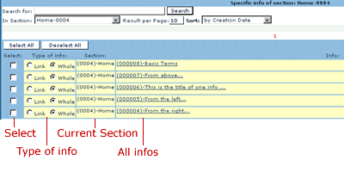
- Info Range A and Info Range B - used for advanced visualization;

You can add infos from a section sorted by Info Position, Alphabetical, by Creation Date, by Publication Date, by Changed Date or Random.

3. After you have selected the way you want to add the section, select the desired box and click on the Add button. Use the Move Up and Move Down arrows to position the section.

4. With the added section still selected click on the Open Styles button, select the desired style and click on Set button.
You can use the Preview button in the upper end of Visualization Management panel. When you are pleased with the results use the Update button to save the changes you have made. A list of sections using this visualization will appear. Click OK to save the changes.
N.B. Changes will apply to all sections that use the Current Visualization!

Site Statistics
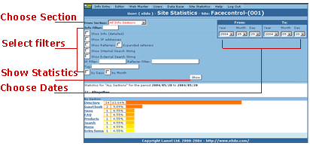
From the Face Control menu choose Statistics>Site Statistics. The shown window will open. Here you can collect different information for the visits of your site. You can view detailed statistics, statistics by IP addresses, statistics of referrers, etc.

1. Select the section you want to collect information for or select All Info Sections to view visits in all sections.

2. Choose the period you want to view statistics for by choosing dates.

3. Select any filter if you want - showing of infos, IP addresses, referrers, etc.

4. Click on the Show button to view generated statistics.

